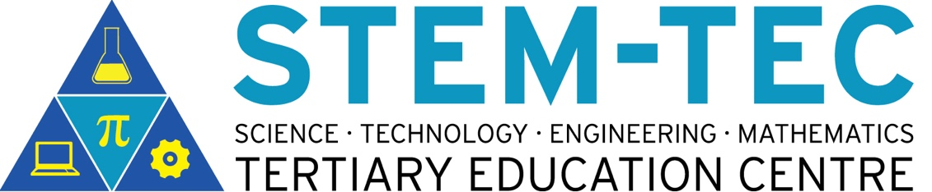

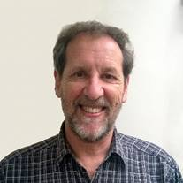STEMTEC Lunchtime Seminar Series, 2017

Where: WT515C

When: 11 April 2017, 12-1pm

Who: Peter Maclaren

Peter Maclaren: the future forms of tertiary STEM education

**ABSTRACT**

We know what the new **Engineering, Technology and Design *building* on St Paul Street** will look like. But what about the future of ***learning and teaching***? What influence might developments in technology, pedagogy and content knowledge have on what we do as educators? This seminar will examine some current research and seek your views on what form tertiary STEM education might take in the future.

**Peter Maclaren** in an Academic Advisor in the AUT Centre for Learning and Teaching. He taught Applied Mathematics for 18 years at AUT (ATI, AIT), before becoming involved with educational technologies and staff development. He has a B.E. (Engineering Science, Auckland), Master of Educational Technology, and Diploma in Teaching (Primary). He is currently enrolled in a PhD, investigating applications of pen-enabled computers in STEM education.

Kober, N. (2015). Reaching Students: What Research Says About Effective Instruction in Undergraduate Science and Engineering. Washington, DC: National Academies Press. Retrieved from <http://www.nap.edu/catalog.php?record_id=18687>

Koehler, M., & Mishra, P. (2009). What is technological pedagogical content knowledge (TPACK)? Contemporary Issues in Technology and Teacher Education, 9(1), 60–70. Retrieved from <http://www.editlib.org/p/29544/>